**Supply Chain Analysis: Data Analysis Case Study using Excel**

**Data Analyst case study on supply chain analysis   
using excel**

**Supply chain analysis of fashion and beauty startup**

**REPORT**

**BY  
Aare Adegboyega Waris**

**Data and Business Intelligence Analyst**

**INDEX**

1. Introduction ………………………………………………………………………… 1

2. Dataset Overview………………………………………………………………………… 1-2

3. Supply Chain Analysis using Excel………………………………….……………. 3

4. Dataset Source ……………………………………………………………………….. 3

5. Dataset Analysis using Excel ……………………………...……………….. 3

6. Analyzing SKUs **…**………………………………………………………… 8

7. Cost Analysis ………………………………………………………………………… 11

8. Analyzing Defect Rate ………………………………………………………….… 13

9. Dashboard ………………………………………………………….… 15

10. Summary ………………………………………………………….… 16

**Introduction**

Supply chain analytics plays a crucial role in driving data-driven decision-making across industries, including manufacturing, retail, healthcare, and logistics. In this report, I present an analysis of a Fashion and Beauty startup's supply chain data, specifically focused on the movement of makeup products. By collecting, analyzing, and interpreting this dataset, I aim to gain insights that can inform strategic decisions and optimize the supply chain operations.

**Dataset Overview**

The dataset comprises various features related to the Fashion and makeup product supply chain. These features provide valuable information for understanding the flow of products from suppliers to customers. The following features are included:

1. Product Type
2. SKU
3. Price
4. Availability
5. Number of products sold
6. Revenue generated
7. Customer demographics
8. Stock levels
9. Lead times
10. Order quantities
11. Shipping times
12. Shipping carriers
13. Shipping costs
14. Supplier name
15. Location
16. Lead time
17. Production volumes
18. Manufacturing lead time
19. Manufacturing costs
20. Inspection results
21. Defect rates
22. Transportation modes
23. Routes
24. Costs

**Supply Chain Analysis using Excel**

The supply chain represents a network of interconnected processes involved in the production and delivery of goods to customers. Analyzing the various components of a supply chain is crucial for identifying opportunities to enhance its effectiveness and generate greater value for customers. In this report I conducted a supply chain analysis using Excel, and gave a valuable insights into optimizing supply chain operations.

**Dataset Source**

To perform a supply chain analysis on this company, it is crucial to gather data related to various stages of the supply chain. This includes information about sourcing, manufacturing, transportation, inventory management, sales, and customer demographics.

Fortunately, I have come across this excellent dataset that provides comprehensive data about the supply chain of a Fashion and Beauty startup.

In the following section, I will guide through the process I use to conduct a supply chain analysis using Excel.

**Dataset Analysis using Excel**

The first step is to import the file into Excel.

After importing the file, the next task is to remove any duplicate entries. To do this, I selected all the data by clicking on cell A1 and then pressed Ctrl+A. Then clicked to the "Data" tab and choose "Remove Duplicates" under the "Data Tools" section. Once duplicates are removed, the next step is to filter the data to identify any spelling errors or unwanted names. To do this, I can clicked on the "Filter" tool under the "Sort & Filter" section. While filtering, I noticed that some entries under the "Customer Demographics" category are labeled as "Unknown" instead of specific demographics like Male, Female or Non-Binary. Since I won't be using this data, I proceeded with the existing information. At this stage, the data cleaning process is considered complete, and I moved on to the next steps.

To facilitate further analysis, I converted the data into a table. I achieved this by selecting the entire data range (Ctrl+A) and then pressing Ctrl+T to convert it into a table. The next step is to create a pivot table. Navigated to the "Insert" tab and select the "PivotTable" tool. Choose the location for the pivot table (such as a new worksheet) and specify the data range (Table 1 or the relevant table name). Once the pivot table is created, I formated the numbers to display as whole numbers and remove any decimal places for better readability.

1. Now, I’m ready to analyze the data and provide insights based on the following requirements or objectives.

I begin the analysis of the Supply Chain by examining the correlation between product prices and the corresponding revenue they generate.

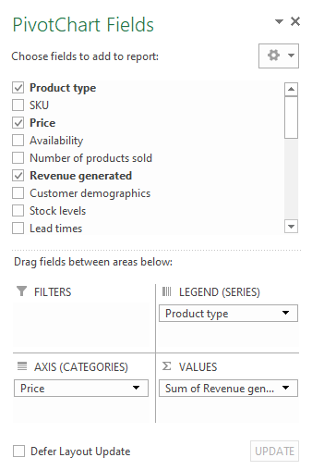

Therefore, the company generates a higher revenue from skincare products, and there is a positive relationship between the price of skincare products and the revenue they generate.

1. Now, I examined the sales based on different product types.

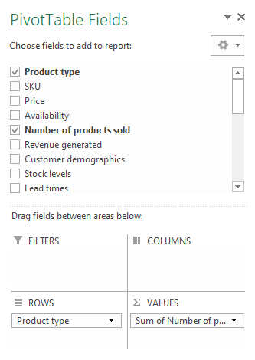

Skincare products account for 45% of the company's business, while haircare products contribute to 29.5% of the revenue, and cosmetics make up 25.5% of the total sales.

1. Now, I analyzed the total revenue generated from shipping carriers.

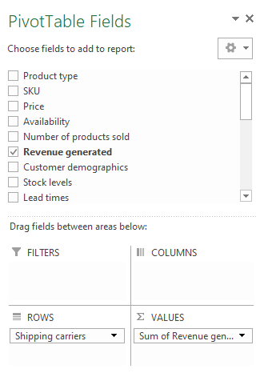

The company utilizes three shipping carriers for transportation, and among them, Carrier B contributes significantly to the company's revenue generation.

1. Now, I examined the average lead time and average manufacturing costs for all products of the company.

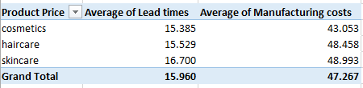

**Analyzing SKUs**

In the dataset, there is a column labeled as SKUs, which stands for Stock Keeping Units. SKUs are unique codes assigned to products to facilitate inventory management and tracking. They serve as a means to identify and differentiate individual items, ensuring accurate monitoring of stock levels. For instance, in a toy store with a diverse range of toys, each toy would be assigned a unique SKU as a secret number known only to the store, enabling efficient inventory control.

1. Now, I analyzed the revenue generated by each SKU.

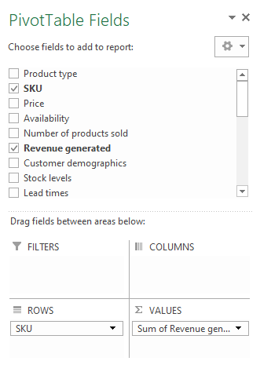

Another column in the dataset is labeled as Stock levels. Stock levels indicate the quantity of products available in a store or business's inventory at a given time

1. Now, I examined the stock levels of each SKU.

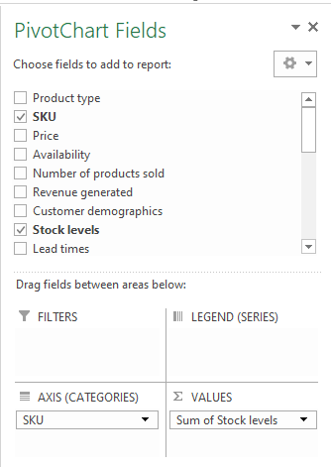

1. Now, I analyzed the order quantity of each SKU.

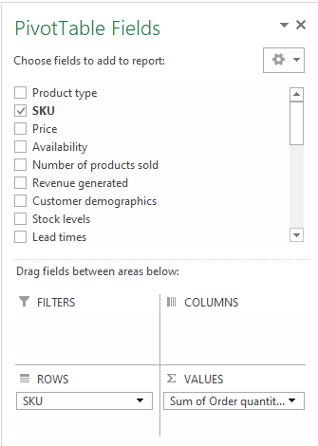

**Cost Analysis**

1. Now, I analyzed the shipping costs associated with different carriers.

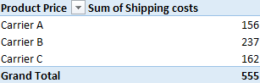

The above visualizations revealed that Carrier B contributes significantly to the company's revenue. However, it is also the most expensive carrier among the three options.

1. Now, I examined the distribution of costs by transportation mode.

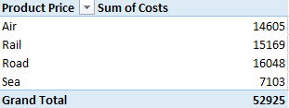

The company allocates a larger portion of its transportation expenses to the Road and Rail modes for the transportation of goods.

**Analyzing Defect Rate**

The defect rate in the supply chain refers to the percentage of products that are found to have issues or are damaged after being shipped.

1. Now, I analyzed the average defect rate across all product types.

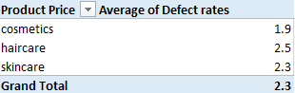

Haircare products have a higher defect rate compared to other product types.

1. Now, I examined the defect rates based on the mode of transportation.

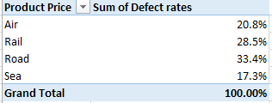

Road transportation exhibits a higher defect rate, while Air transportation demonstrates the lowest defect rate. This showcases how Excel programming language can be utilized to analyze a company's supply chain.

**Dashboard**

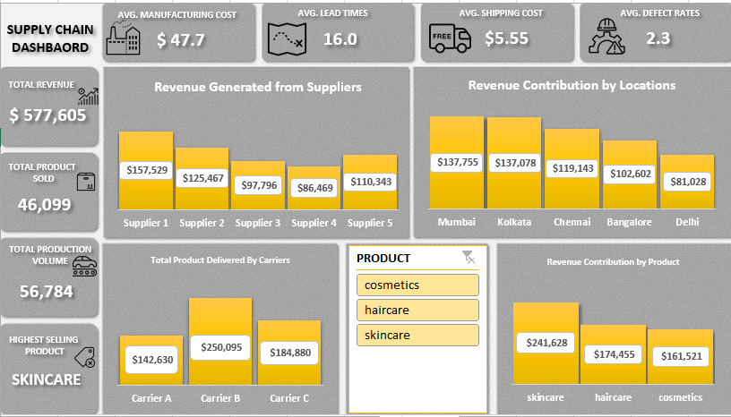

I used the dashboard to highlight some important insights which are;

1. Total Revenue
2. Total Product Sold
3. Total Production Volume
4. Highest Selling Product
5. Average Manufacturing Cost
6. Average Lead Time
7. Average Shipping Cost
8. Average Defect Rates

Also, I used the dashboard to highlight some important revenue insight which are;

1. Revenue generated from each suppliers
2. Revenue generated from each locations
3. Revenue generated from each company product
4. Total Product delivered by each carriers

**Summary**

Supply Chain Analysis involves examining different aspects of a supply chain to identify areas for improvement and enhance the overall efficiency of the supply chain, ultimately delivering greater value to customers. This report provided an overview of conducting a supply chain analysis using Excel, highlighting key steps and techniques and revenue generated.

If you have any questions or would like to contribute further insights, please feel free to reach out.